How to Run the Application
How Import the Data
Click on the Extension Icon


The following dialog will be opened. Enter the system User Id and Password and click on Upload button. Data will be uploaded into system background.
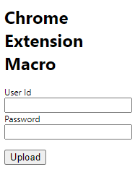
Note: Whenever Module Id information is changed, there user must import data using above options. i.e. whenever “PW1100G IMRO Engineering Master.xlsm” and “PW1100G IMRO.xlsm” information is updated.
How Run the Application.
Select any DMC number in chrome from Engine Manual, right click, click on “Chrome Extension – Module ID” -> “Find Module ID for DMC”
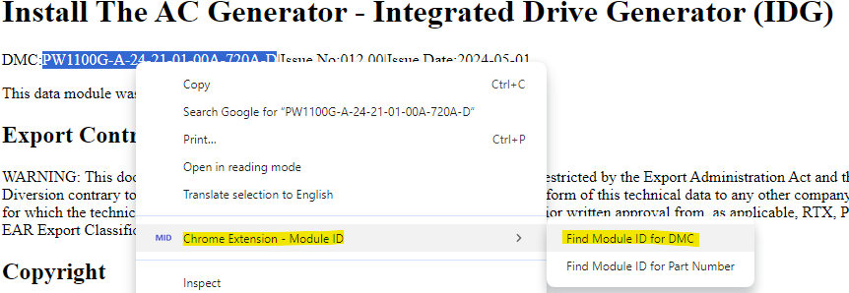

the following output will be shown
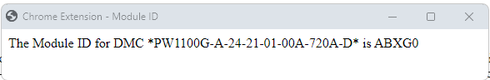
Similarly, user get the module ID for part number as well using “Find Module ID for Part Number”
